**Experimental Study**

**3.1 Introduction**

This chapter presents the details of experimentation for investigating the various characteristics of SIFCON at normal and elevated temperature conditions. From the detailed review of literature, it is concluded that there is need to assess properties of SIFCON with locally available materials. In this investigation the natural sand is completely replaced by manufactured sand. The investigated strength characteristics of SIFCON are compressive strength, Split tensile strength, Flexural strength, loss of weight of the specimens before and after exposing to elevated temperature. Stress-strain behavior of SIFCON under compression is also studied. Each SIFCON mix is prepared using locally available plain steel fibres, with three percentage fibre volume fractions, i.e. 8 %, 10 % and 12 %.

This chapter is organized as follows. The various materials used in the experimentation are cement, sand (fine aggregate), mixing water, chemical admixture and steel fibres. The complete experimental program of the research has been discussed in sections 3.2 and 3.3. The various tests that were performed to evaluate the strength properties of SIFCON are discussed in section 3.4. The effect of elevated temperature on the mechanical properties is discussed in section 3.5 and finally concluded in section 3.6.

**3.2 Materials**

The constituent materials of SIFCON used in this investigation are steel fibres, cement-sand based slurry, high range water reducing admixture to improve the flow ability of the slurry. The properties of these materials are presented in the following sections.

**3.2.1 Cement**

The cement used in all mixes of the study is Ordinary Portland Cement of grade 43. The cement was tested for various properties as per the requirements of IS 8112-1989. The physical of the cement used are presented in Table 3.1 and its chemical composition is presented in Table 3.2.

Table 3.1 Physical properties of cement

|  |  |  |  |
| --- | --- | --- | --- |
| **S.No.** | **Characteristics** | **Test result** | **Suggested values as per I.S Specification** |
| 1 | Specific gravity | 3.10 | -- |
| 2 | Fineness of cement | 3% | <10.0% |
| 3 | Normal consistency | 32% | --- |
| 4 | Initial setting time | 168 minutes | >30 minutes |
| 5 | Final setting time | 270 minutes | <600 minutes |
| 6 | Compressive strength  3-Days  7-Days  28-Days | 24.80 N/mm2  34.15 N/mm2  49.80N/mm2 | 23.0 N/mm2  33.0 N/mm2  43.0 N/mm2 |

Table 3.2 Chemical analysis of cement

|  |  |  |
| --- | --- | --- |
| **S.No.** | **Chemical analysis of cement** | **(%)** |
| 1 | Loss of Ignition (LOI) | 1.55 |
| 2 | Insoluble residue | 2.0 |
| 3 | Magnesium Oxide (MgO) | 1.4 |
| 4 | Lime saturation factor | 0.87 |
| 5 | Alumina Iron Ratio | 1.0 |
| 6 | Sulphuric Anhydride | 1.9 |
| 7 | Alkalies | 0.6 |
| 8 | Chlorides | 0.01 |

**3.2.2 Aggregate**

As the availability of river sand is getting depleted day by day, manufactured sand is used as an alternative to the river sand in the present experimentation.

Manufactured sand is manufactured in a local crusher plant by crushing quartz by making use of the Vertical Shaft Impact (VSI) crusher. Due to the use of this technology the sand particles can be shaped very similar to that of the naturally available fine aggregate. During the process of manufacturing, sieving is done using water jet and the fine separation by screw classifiers. The sand obtained by means of this method is clean, durable and has the desired particle size distribution. Using this method, sand falling in any Zone can be manufactured according to our requirement. Manufactured Sand used for the present study is manufactured as fine aggregate falling under Zone II, confirming to the requirements of IS: 383-1970. A report on sieve analysis is given in Table 3.3 and the grading curve is shown in Fig.3.1.

Table 3.3 Results of sieve analysis of manufactured sand

|  |  |  |  |  |  |
| --- | --- | --- | --- | --- | --- |
| S.No. | Sieve Size | Weight of material retained (grams) | % weight of material retained | Cumulative % of weight of material retained (a) | % Cumulative passing (100-a) |
| 1 | 10 mm | 0 | 0.00 | 0.00 | 100 |
| 2 | 4.75 mm | 5 | 0.50 | 0.50 | 99.5 |
| 3 | 2.36 mm | 81 | 8.10 | 8.60 | 91.4 |
| 4 | 1.18 mm | 216 | 21.60 | 30.20 | 69.8 |
| 5 | 600µ | 193 | 19.30 | 49.50 | 50.5 |
| 6 | 300µ | 282 | 28.20 | 77.70 | 23.3 |
| 7 | 150µ | 223 | 22.30 | 100.00 | 0.00 |
| Total | | | | 266.5 |  |
| Fineness Modulus | | | | 2.665 |

Figure 3.1 illustrates the grading curves of the manufactured sand used for making SIFCON mixes.



Fig.3.1 Grading curve of manufactured sand

Sieve analysis, fineness modulus, specific gravity and bulking tests were conducted for the manufactured sand in accordance with the standard test method as per IS: 2386 (Part III) -1963. Table 3.3 presents the properties of manufactured sand.

Table 3.4 Physical properties of manufactured sand properties

|  |  |  |
| --- | --- | --- |
| **S.No.** | **Property** | **Test result** |
| 1 | Sieve analysis | Zone II |
| 2 | Fineness modulus | 2.665 |
| 3 | Specific gravity | 2.57 |
| 4 | Bulking of sand | 36% at 4% of water added |
| 5 | Bulk density | |
| 1. Loose 2. Compaction | 1.54 kg/m3  1.73 kg/m3 |

**3.2.3 Mixing water**

The local tap water is used as the mixing water. It is drinkable, clear and apparently clean, and does not contain any substances in excessive amounts that can be harmful for making concrete. The results of various tests are presented in Table 3.5.

# Table3.5 Physical Properties of Water

|  |  |  |
| --- | --- | --- |
| **Sl. No** | **Parameter** | **Amount** |
| 1 | pH | 7.0 |
| 2 | Taste | Agreeable |
| 3 | Appearance | Normal |
| 4 | Turbidity (NT Units) | 4 |
| 5 | Colour (Hazen Units) | 2 |
| 6 | Hardness (mg/l) | 1 |
| 7 | Sulphates (mg/l) | 0.3 |
| 8 | Chlorides (mg/l) | 9 |

**3.2.4 Chemical admixture**

Requirement of workability is the essence of good concrete. Only one type of Superplasticizers (SP) is used in this study. In the present study, high range water reducing superplasticizing admixture named CONPLAST X421IC produced by Fosroc Chemicals Pvt. Ltd. CONPLAST X421IC is used. It is a ready-to-use liquid admixture that meets the requirements of IS: 2645-2003. This is used for concrete or mortar where flowing properties are required.

**3.2.5 Steel Fibres**

Numerous trials were made in the preliminary stages of the research in order to choose the appropriate fibre type. Fibres used in making SIFCON have to be in a loose state (single or discrete) in order for the mixture to infiltrate into the fibre bed without clogging or honeycombing. In addition, it is necessary to choose fibres with equal aspect ratio, so that uniformity is maintained while placing the fibres in the sample moulds. Finally, the decision is taken to work on plain steel fibres of individual form, having similar dimensions, as shown in Fig. 3.2. The properties of the plain steel fibre are presented in Table 3.6. The plain fibres are obtained by cutting the binding wire for the required aspect ratio. The binding wire has been manufactured by Vizag steels, Visakhapatnam. The volume fractions of fibre are calculated based on the density of steel fibres which is taken as 7850 kg/m3.

Table 3.6 Properties of Steel binding wire fibre

|  |  |  |
| --- | --- | --- |
| **S.No.** | **Fibre type** | **Steel fibre** |
| 1 | Section shape | Circle |
| 2 | Length (mm) | 50 |
| 3 | Diameter (mm) | 01 |
| 4 | l/d (aspect ratio) | 50 |
| 5 | Tensile strength (MPa) | 417MPa |

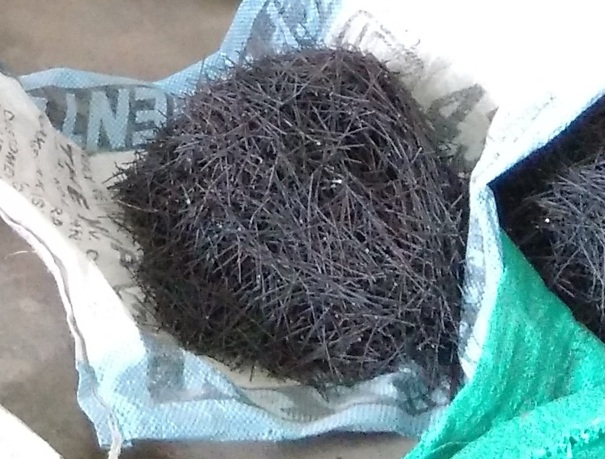

Fig. 3.2 Steel Fibres

**3.3 Experimental program**

The first step in the experimental study is to prepare some trial mixes to reach final decision on the details of mix proportions. Type and volume fractions of steel fibre to be used, the dimensions and types of moulds, etc are also decided after preparing the trial mixes. In the subsequent paragraphs, the details of the experimental program are presented.

**3.3.1 Mix proportions**

In order to study the behaviour of SIFCON produced with locally available low strength steel binding wire as fibre and manufactured sand, a total of three SIFCON mixes have been tried. The SIFCON mixes are prepared using plain steel fibres, with three fibre volume fractions viz., 8%, 10%, and 12%.

It is found that the minimum practical limit that fills the moulds without using vibration is about 8%. On the other hand, 12% volume fraction is approved as a maximum practical limit, even with intense vibration. After making a number of trials with different volume fraction of fibres, it is observed that beyond 12% fibre volume, placing of fibres manually in the moulds is very tedious and uniform mixing of fibres cannot be achieved. In addition to these two extremes, 10% is taken as an intermediate fibre content which could be achieved with light tamping during fibre placement into the moulds. For every test assigned in the experimental program, several specimens were prepared out of each batch in order to perform the required tests. Table 3.7 presents the Mix proportion of SIFCON mixes, and the quantities of the constituents (in kg/m3) used in the study respectively.

Table 3.7 Proportions of SIFCON mixes

|  |  |  |  |  |  |  |
| --- | --- | --- | --- | --- | --- | --- |
| **S.No.** | **Designation (Specimen)** | **Mix proportion** | **Fibre** | **Water cement ratio** | **Plasticizer content** | **Mode of vibration** |
| 1 | SIFCON8 | Cement and sand (1:1 by weight) | 8% | 0.5 | 0.6% | Hand tamping |
| 2 | SIFCON10 | Cement and sand (1:1 by weight | 10% | 0.5 | 0.6% | Hand tamping |
| 3 | SIFCON12 | Cement and sand (1:1 by weight) | 12% | 0.5 | 0.6% | Hand tamping |

The first letter in the mix designation indicates the type of matrix used i.e. SIFCON. The second letter in the mix designation indicates the percentage of fibre used in the mix. In all the three mixes the ratio of binder to sand is kept as constant at 1:1. The relative proportions of binder, water and sand are calculated by absolute volume method. In this investigation three different volume percentages of fibres viz. 8, 10 and 12% have been used with an aspect ratio of 50.

**3.3.2 Preparation and casting of test specimens**

The details about the preparation of test specimens are presented in the following sections.

The first step in preparing SIFCON is placing the fibres in the moulds up to the required volume fraction. In this investigation fibres are placed randomly in the moulds manually. No vibration was imposed during fibre placement for the specimens with fibre fractions to ensure filling the moulds without large voids. The three types of mixes explained above have been used for producing slurry with water-binder ratio of 0.5 along with a high range water-reducing admixture. The slurry so prepared has been infiltrated into the preplaced fibres into the moulds individually. The weight of steel fibre to be put in the mould depends on the required volume fraction, the dimensions of the mould, and, of course, on the specific gravity of the steel itself.

**3.3.2.1 Casting**

The cubes are cast in steel moulds of inner dimensions of 150mm x 150mm x 150mm, the cylinders are cast in steel moulds of inner dimensions of 150 mm diameter and 300mm height and the prisms are cast in steel moulds of inner dimensions of 100 mm x 100 mm x 500mm. The details of fabrication and casting are presented in Figs. 3.3 to 3.7.

**3.3.2.2 Curing**

The specimens are removed from moulds after 24 hours and the specimens are kept immersed in a water tank. After curing the specimens in water for a period of 28 days, the specimens are taken out and allowed to dry under shade. Three cubes, three cylinders and three prisms are cast for each mix for each curing period and the average strengths have been considered. Similarly specimens are cast for residual strength of SIFCON as that of specimens at normal condition.

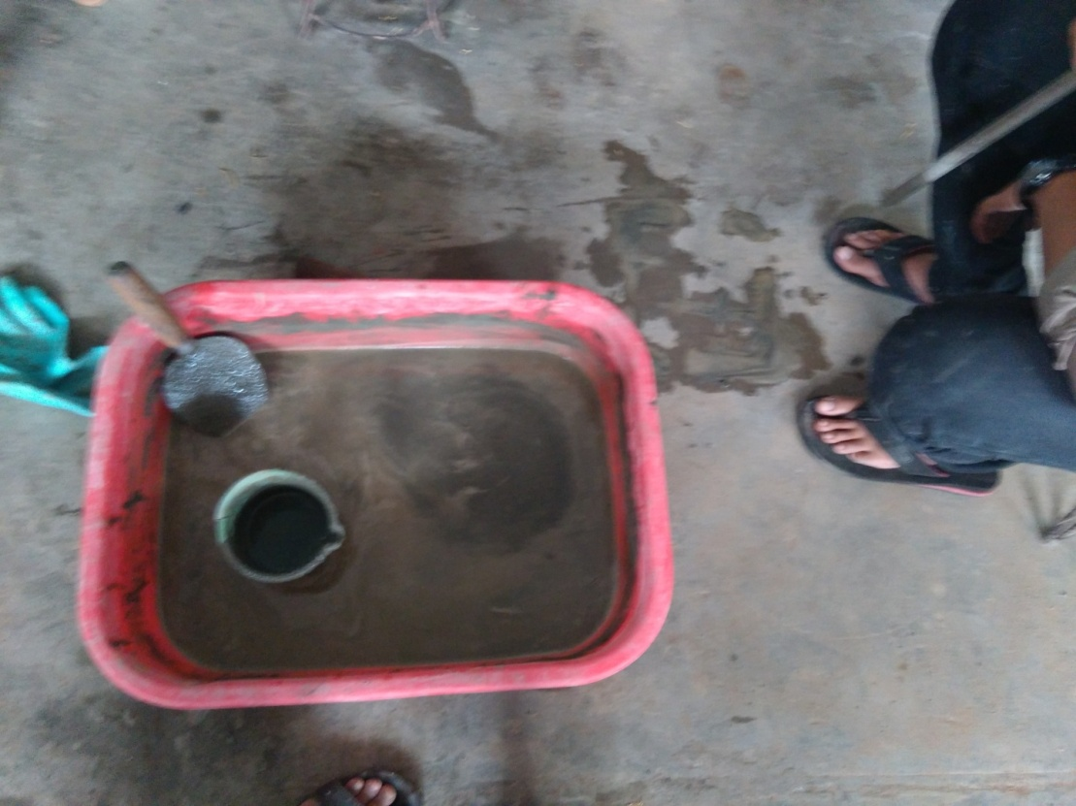

Fig.3.3 Slurry paste

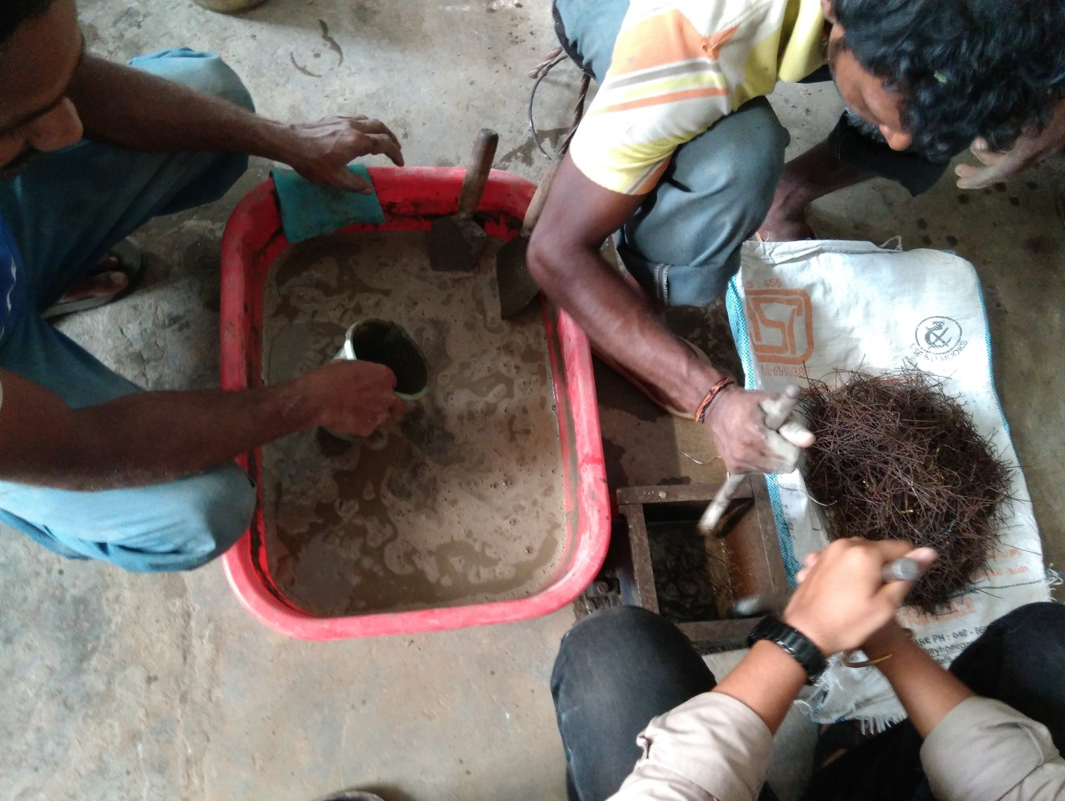

Fig. 3.4 Slurry infiltration process

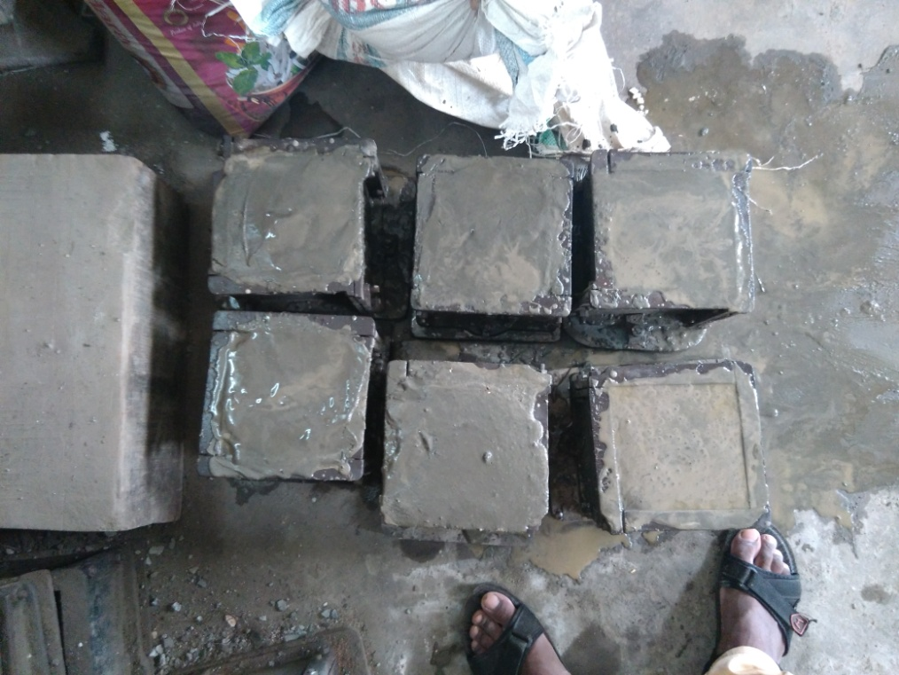

Fig.3.5 Cube Specimens

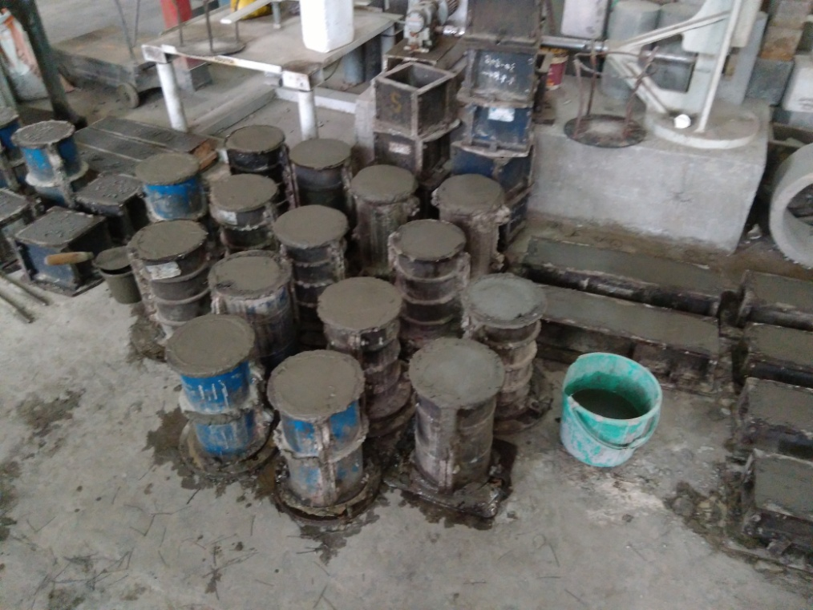

Fig.3.6 Cylinder Specimens

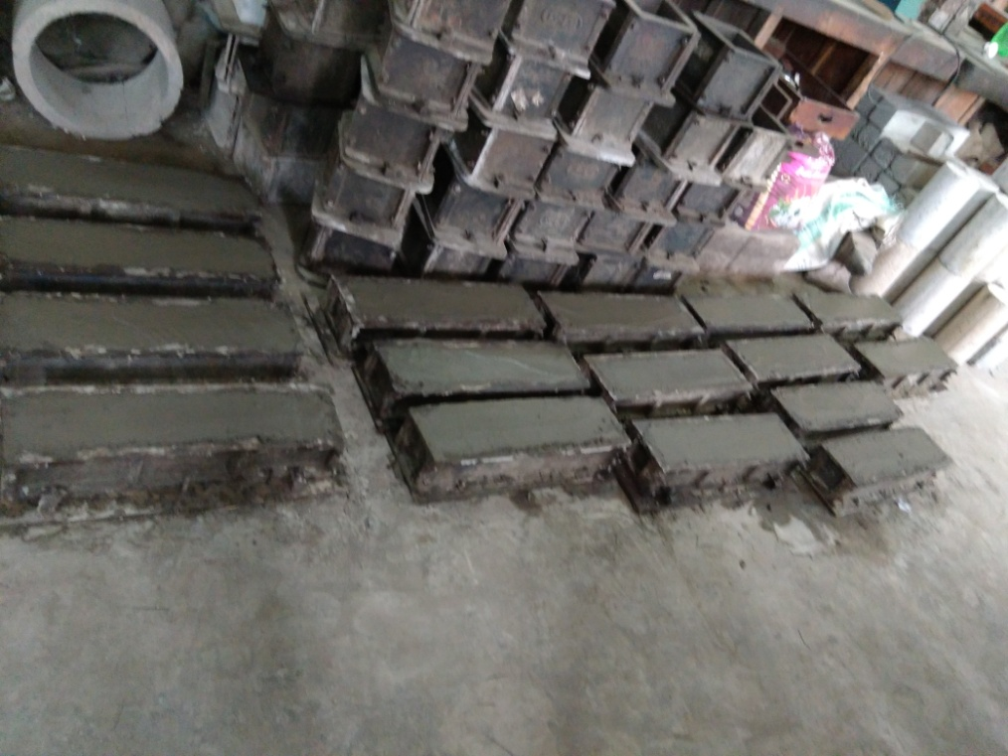

Fig.3.7 Prism Specimens

**3.4 Experimental tests**

The experimental program consists, first of all, of investigating the strength properties of SIFCON and stress-strain relationships. Further the effects of the elevated temperature on the mechanical properties of SIFCON are also studied. A series of tests related to strength characteristics are performed on SIFCON samples are as follows

(a) Compressive strength.

(b) Split tensile strength.

(c) Flexural strength.

(d) Stress strain relationships.

(e) Residual compressive strength

(f) Residual Flexural strength

(g) Residual Split tensile strength

The following sections discuss the details about the above mentioned tests in brief.

**3.4.1 Compressive Strength**

The specimens that are used for the tests are 150 mm size cubes. The machine used for conducting the test is Compression Testing machine with a maximum load of 300T as shown in Fig. 3.8. The compressive strength test is conducted in accordance with IS 516-1959. The cube is placed in the machine and the load is applied at a constant rate of 140 kg/sq.cm/min until the ultimate load is achieved i.e. the load at which the cube fails to take on any further load. The same process is carried out for all the cube specimens. The compressive strength in respect of all SIFCON mixes is obtained at curing periods of 7, 28 and 56 days. Using the ultimate load of the specimen, the compressive strength of the cube is calculated by using the following formula

 (3.1)

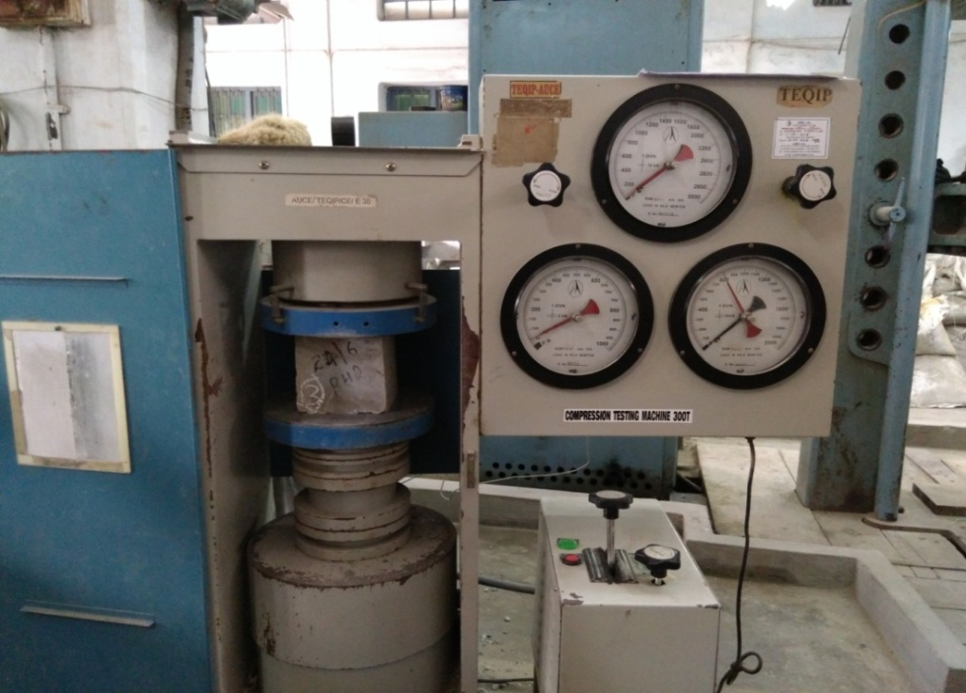

Fig 3.8 Compression strength test setup

**3.4.2 Split Tensile Strength**

The cylinders were tested for every percentage of fibre volume fraction at the ages of 7, 28 and 56 days. The test is carried out by placing a cylindrical specimen horizontally in the Compressive testing machine of 300T capacity as shown in the Fig. 3.9. The load is applied to the cylinder specimens at a constant rate 14-21 kg/cm2/minute until the cylinder fails to take on any further load. The failure of the specimens is noticed by a vertical crack on the diameter of the specimen. The entire test for determining the split tensile strength is performed as per the IS: 5816-1970. The dimensions of the cylindrical specimen used for the test are of 150 mm in diameter and 300 mm in length. Using the ultimate load that is applied to test, the split tensile strength is calculated using the formula.

 (3.2)

where,

P = applied load (N)

D = diameter of the specimen (mm)

L = length of the specimen (mm)

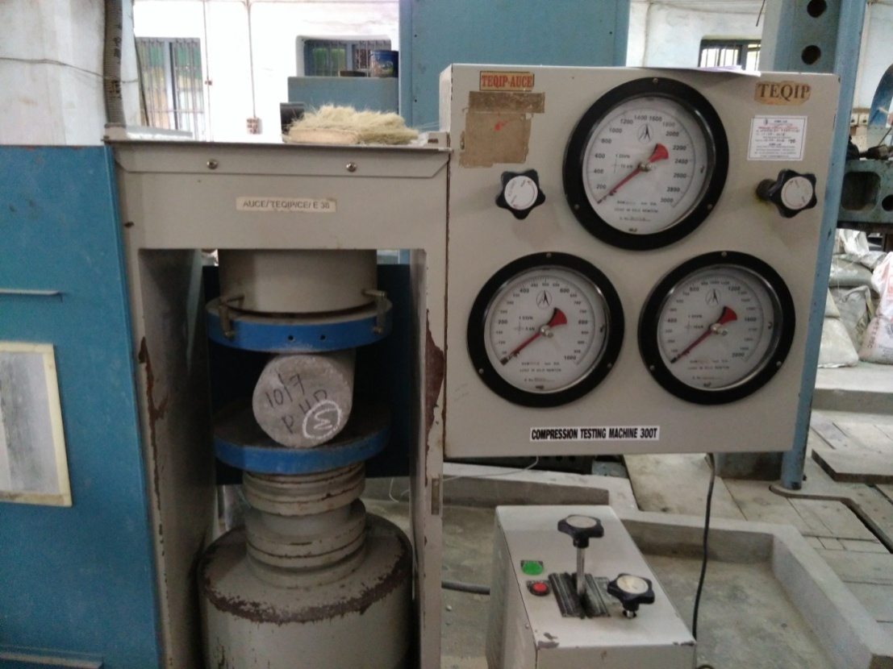

Fig 3.9 Split tensile strength test setup

**3.4.3 Flexural Strength**

The Flexural strength that is conducted for curing period of 7, 28 and 56 days for all the SIFCON mixes having 8%, 10% and 12% of fibre fraction. The test is carried out by placing a prism specimen horizontally in the Universal testing machine as shown in the Fig. 3.10. Universal testing machine of 10T capacity is used for conducting the test. The load is applied to the prism specimen at a constant rate of 180 kg/min until the prism fails to take on any further load. The failure of the specimens is noticed by a crack on the bottom surface of the specimen projecting upwards which leads to the breaking of the specimen. The entire test for determining the flexural strength is performed as per IS: 516-1959. The dimensions of the prism specimen used for the test are of 500 × 100 ×100 mm. For this prism specimen, the flexural strength is calculated with the help of the formula given below.

 for **a** > 130 mm (3.3)

and

 for 110mm < **a** > 130 mm (3.4)

where,

P = maximum Load (kg)

a = the distance between the line of fracture and the nearer support, measured on the centre line of the tensile side of the specimen

b = width of specimen (mm)

d = failure point depth (mm)

l = supported length (mm)

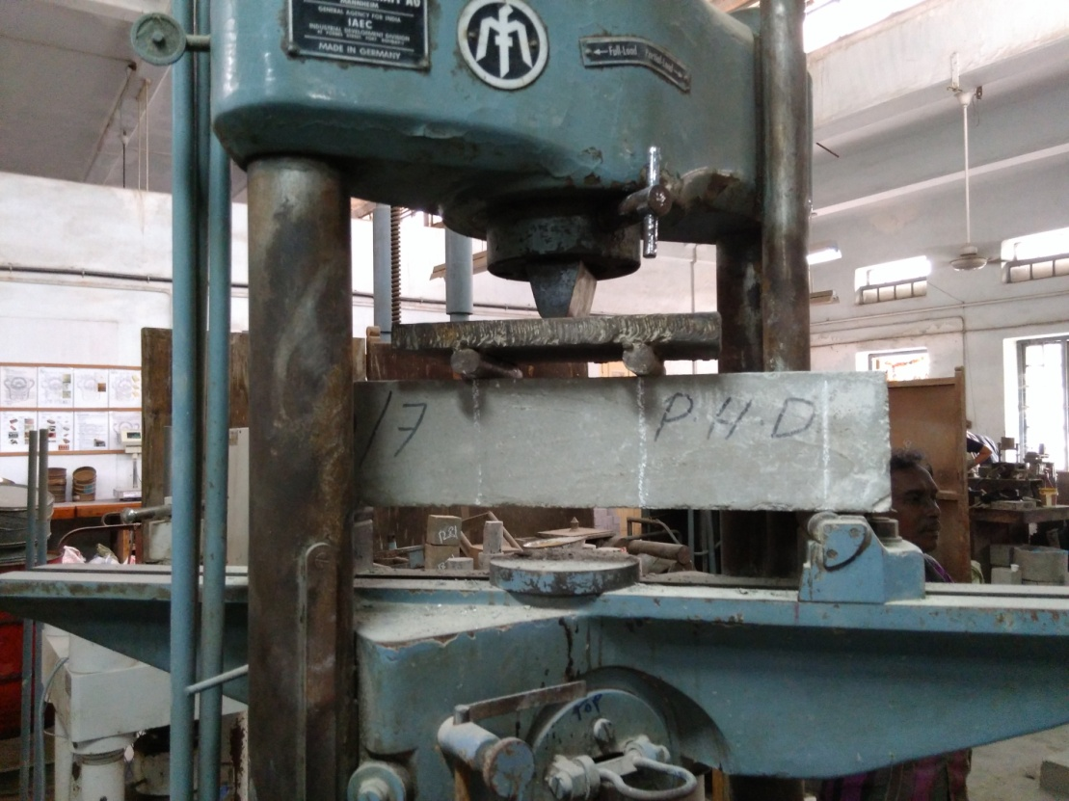

Fig 3.10 Flexural strength test setup

**3.4.4 Modulus Elasticity**

SIFCON is characterized generally with its high strength and very high strain capacity. Although stress-strain relationships are related to the mechanical properties of the materials, rather than their durability, the aim of this investigation is only to ensure that the procedures followed in preparing SIFCON would lead to a material with mechanical properties similar to what is known from the literature (Fanam et.al., 2010). Consequently, stress-strain properties of SIFCON in compression are studied. A complete set of cylindrical SIFCON specimens having dimensions of 150 × 300 mm is prepared for conducting stress-strain test.

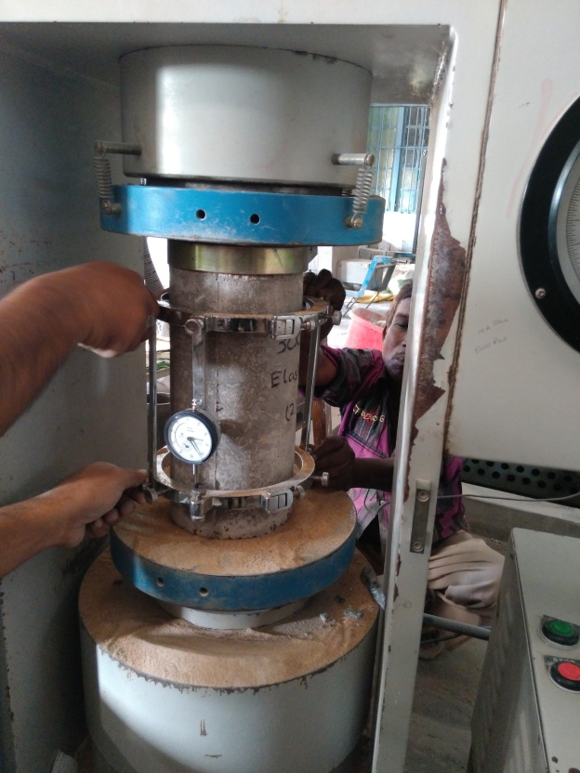

Fig 3.11 Testing system

The compression specimens are cast in cylindrical iron moulds. After infiltration, as discussed earlier, the specimens are covered with plastic sheets to aid in curing. The specimens are left to cure for 24 hours in the moulds in the laboratory environment. Next day the specimens are demoulded, labeled, and placed in water for 28 days for curing until testing. Actually, this procedure has been the same for all the other tests, with the exception of the curing period in some cases. After the curing period, all specimens are tested in compressometer. Prior to testing, the top and bottom surfaces of all specimens are capped with fine sand to ensure even surfacing to the loading surfaces. The testing system shown in Fig. 3.11 consists of a hydraulic universal testing machine connected to a data acquisition system adjusted to take one reading every 10kN. During the tests, load and deformation data are recorded and stored by the said system. The deformation of specimens is measured by two linearly variable differential transducers (LVDT’s) of 150 mm range placed so as to measure the actual specimen deformation between the upper and lower loading platens as shown in Fig.3.8. The average of the two LVDT readings is considered in calculating the strain and it is obtained by dividing the average plate displacement by the original specimen length.

**3.5 Effect of Elevated Temperature**

Concrete is a material often used in the construction of high rise buildings and special purposes, which may be exposed to increasing high temperature. In the cases of unexpected fire, the property of concrete changes after fire, and therefore it is important to understand the change in the concrete properties due to extreme temperature exposures. To predict the response of structure after exposure to high temperature, it is essential that the strength properties of SIFCON subjected to high temperatures be clearly understood. High temperature can cause the development of cracks and these cracks like any other cracks may eventually cause loss of structural integrity and shortens the service life. The influence of elevated temperatures on mechanical properties of SIFCON is very much important for fire resistance studies and also for understanding the behavior of structures like storage tanks for crude oil, hot water, coal gasification, liquefaction vessels used in petrochemical industries, foundation for blast furnace and coke industries, furnace walls of industrial chimney and air craft runway etc. The variations of compressive strength and performance of some of the important parameters have to be investigated when SIFCON structures are subjected to elevated temperatures. Fibres have extensively been used to improve the ductility of concrete. Recently, it has been found that a number of fibres can also improve the residual properties of concrete after exposure to elevated temperatures. Steel fibres in the SIFCON reduce spalling and cracking and enhance the residual strength.

**Colour Change:** As temperature increases colour of concrete changes. At 300°C the concrete colour doesn’t change noticeably however when temperatures are increased up to 400°C the colour slightly changes to dust colour or brownish/ yellowish grey. Certain colours correspond with specific temperature ranges, this is an important indicator of the maximum temperature, which the structure is exposed to.

**Spalling:** Spalling is a damage where concrete surface scales and falls off from the concrete along with explosion at high temperature. High strength concrete appears to be more prone to spalling in fire than normal strength concrete (Sanjayan and Stocks, 1993) and for high performance concrete the spalling will start when temperature is reached 600°C (Lau and Anson, 2006, Sideris et al. 2009). This has two effects: a physical effect due to reduced Van der Waals’ forces as water expands upon heating, and a chemical effect whereby detrimental transformations take place under hydrothermal conditions.

The specimens used in determining the effects of elevated temperatures are cubes (150 × 150 × 150mm), cylinders (150 × 300 mm) and prisms (100 × 100 × 500 mm) of different SIFCON samples.

**3.5.1 Use of fibres and confinements**

The use of fibre exhibits different behavior when subjected to elevated temperature. The inclusion of steel fibres in concrete cannot reduce the risk of spalling, but they can contain the spread of cracking, and potentially improve the performance of concrete, when exposed to high temperatures (Lau and Anson 2006, Sideris *et. al*. 2009, Kodur and Sultan 2003, Hertz 1992). Steel-fibre-reinforced concrete also showed the highest energy absorption capacity after being exposed to the high temperature, although they suffered a quick loss of this capacity after exposing to 800°C (Poon *et. al.* 2001). It can be therefore concluded that the inclusion of steel fibre in the concrete mix leads to an improvement in mechanical properties and provides better resistance to heating effects.

**3.5.2** **Electric furnace**

The electric furnace is used to heat the specimens. Initially specimens were heated at constant rate of 4°C to 10°C per minute to set temperatures. After reaching the target temperature, the specimens were kept at the set temperature for 60 minutes, 2hours and 3 hours respectively to ensure uniform heating within the specimen. After heating, specimens were taken outside from the furnace and air cooled to bring the temperature of the specimens to ambient temperature.

**3.5.3 Residual strength**

In the present study SIFCON specimens were heated in an Bogie Hearth electric furnace (10500C) for different periods of time (1, 2 and 3 hours), at temperature degrees (100 C°, 200 C°, 3000 and 400 C°). The % residual strength of SIFCON is expressed as % of their respective 28-days strength of control specimens at room temperature.

**3.6 Conclusions**

The tests conducted on constituents of SIFCON used in the present study are presented in this chapter. Also experiments are performed on materials used in the present study to produce SIFCON made with locally available manufactured sand for their use in ANN application.